Lab 01: Initial Setup

Network Infrastructure Security (TI-CSP)
2025-2026

© Henk Brouckxon, Nico Declerck, Chris Roets

Introduction

Lab concept
During this lab, we will get acquainted with the NIS lab environment and its systems. We’ll also look into some best-practice configurations with regard to remote management of servers.

Learning goals
- Network discovery with nmap
- Getting acquainted with the NIS lab platform
- Getting acquainted with a new Linux distro for servers 😊
- SSH private key authentication

Practicalities and prerequisites
You will need the following:
- Access to the Cyberops lab environment (or build your own virtual network)

Physical lay-out of the Cyberops lab network
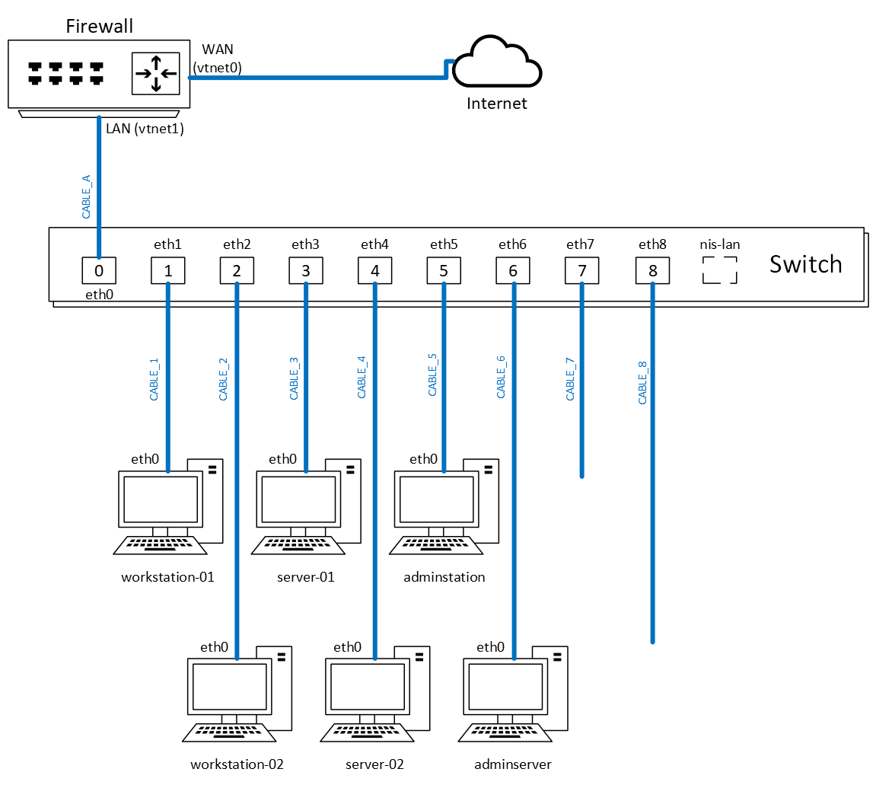
Figure 1 Equivalent physical layout for the Cyberops network

Logical lay-out of the Cyberops lab network (initial setup)
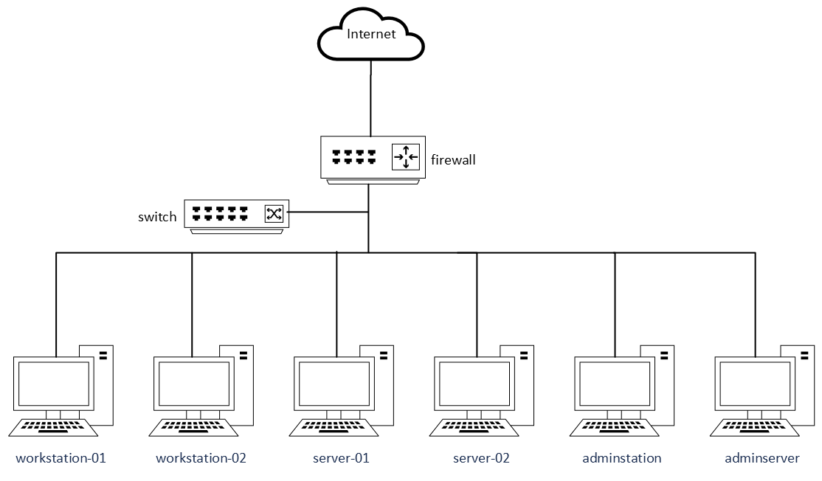
Figure 2 Equivalent logical layout for the Cyberops network

A first exploration of the Cyberops environment

- Connect to your assigned lab environment and start up the following virtual machines (VMs):
- 100 (firewall.nis.net)
- 101 (network.nis.net)
- 110 (workstation-01.nis.net)
- 111 (workstation-02.nis.net)
- 120 (server-01.nis.net)
- 121 (server-02.nis.net)
- 130 (adminserver.nis.net)
- 131 (adminstation.nis.net)

Do not start VM 102 (switch.nis.net), since this will cause problems and may crash your environment.

- Log in to the console of the adminstation machine (VM 131) as the “mickey” user (password “rootroot”), with the credentials that are given in the VM notes (VM “summary” tab). By default this VM uses an AZERTY keyboard layout. Change this if necessary. All other VMs will be keyboard independent.

- In general, it is a good practice to always use personalized accounts, even for admin users. This allows logging who changed certain settings and allows for easier management of who has access to what systems when the person’s role in the organization changes. Now create your own administrator user account for adminstation, with your proxmox host’s DNS name (e.g. “prx-henk-brouck”) as the username. From now on, you should use this personalized user whenever possible, and not the mickey user.
Important remark: in scored submissions of screenshots, we will require you to always use this account to prove that you performed the labs on your own environment.

- Use nmap from the adminstation VM to scan all active hosts in the current subnet. The output of the nmap command should be limited to the lines containing hostnames and IP addresses of the machines. Insert a screenshot of the command and its output here.
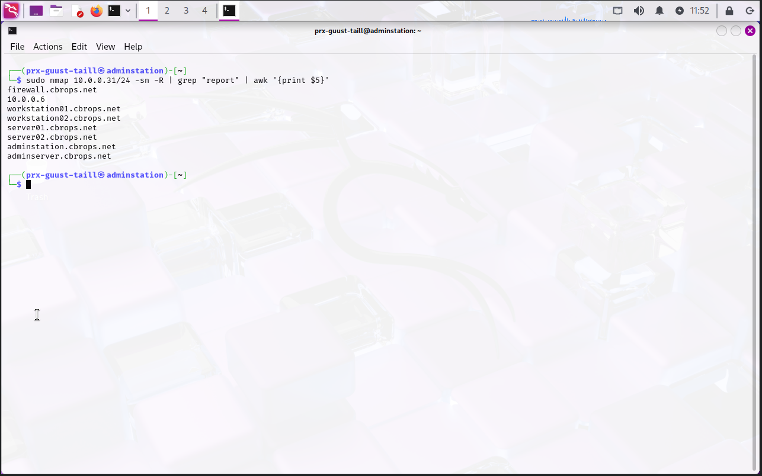

- ² Use nmap on the adminstation VM to find which machines are hosting a website on the default HTTP port
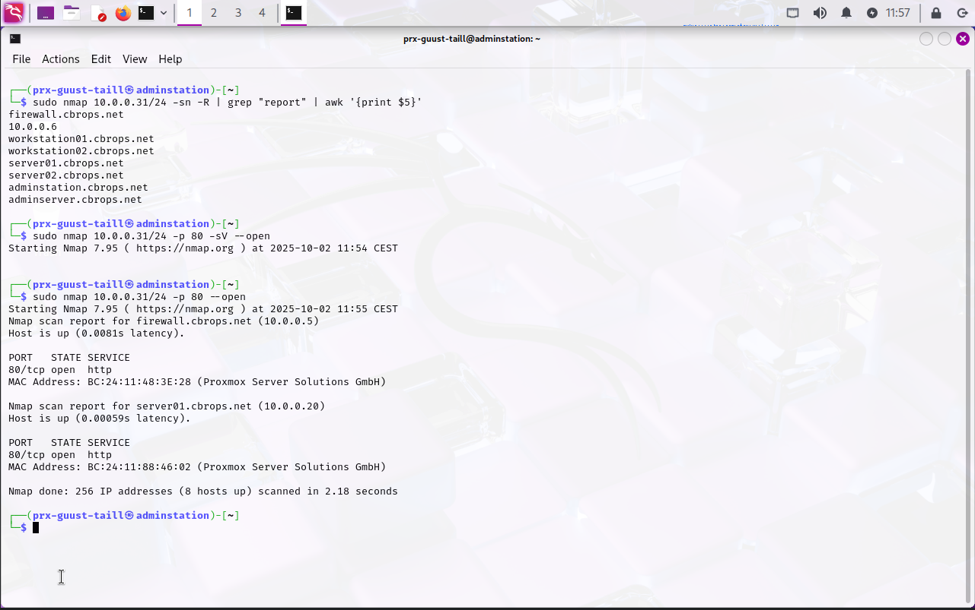
- Use nmap on the adminstation VM to find which machines are hosting an SSH server on the default port
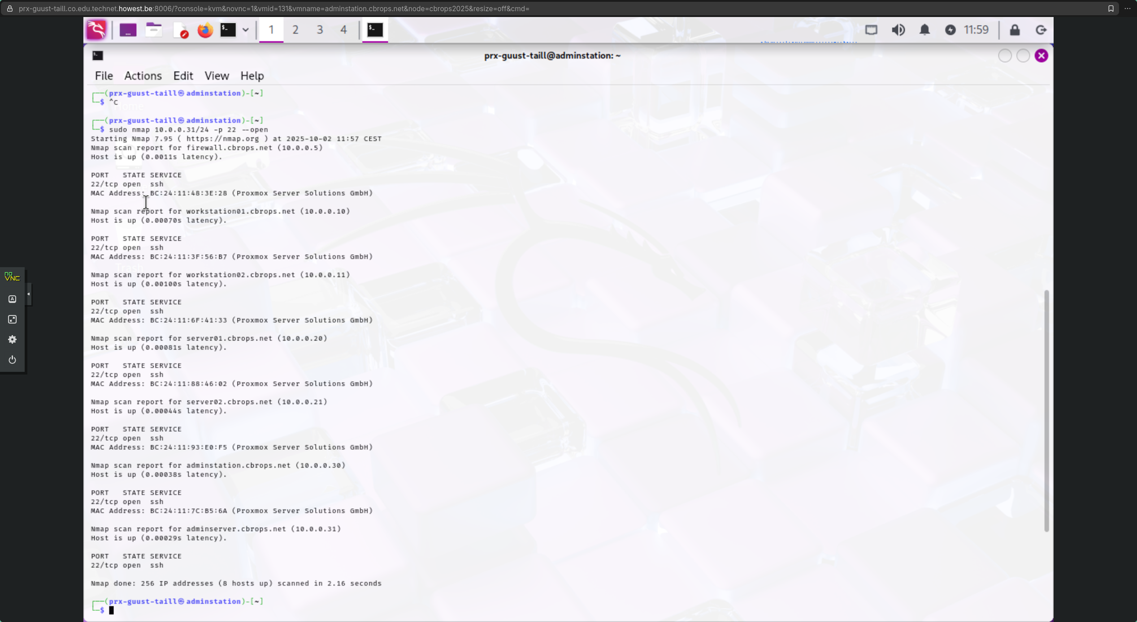

- What operating systems can you detect with nmap for the different hosts? For some of the hosts, this information will be generic/incomplete or even blatantly wrong, probably because many of our VMs run as containers. Fill out the following documentation table as much as possible for the systems you’ve detected, without directly logging in to the different systems (not all information will be available yet)

hostname | IP address | Subnet mask | Default Gateway | DNS | Operating System
firewall | 10.0.0.5 | 10.0.0.255 | 10.0.0.5 | 10.0.0.5 | FreeBSD 11.2 (97% match)
/ | 10.0.0.6 | 10.0.0.255 | 10.0.0.5 | 10.0.0.5 | ???
workstation01 | 10.0.0.10 | 10.0.0.255 | 10.0.0.5 | 10.0.0.5 | Ubuntu 3.2
workstation02 | 10.0.0.11 | 10.0.0.255 | 10.0.0.5 | 10.0.0.5 | MikroTik RouterOS 7.2 – 7.5
server01 | 10.0.0.20 | 10.0.0.255 | 10.0.0.5 | 10.0.0.5 | MikroTik RouterOS 7.2 – 7.5
server02 | 10.0.0.21 | 10.0.0.255 | 10.0.0.5 | 10.0.0.5 | Linux OpenWrt 21.02
adminstation | 10.0.0.30 | 10.0.0.255 | 10.0.0.5 | 10.0.0.5 | Linux
adminserver | 10.0.0.31 | 10.0.0.255 | 10.0.0.5 | 10.0.0.5 | Linux
Table 1 Host documentation (initial nmap info)
- Log in directly to the terminal of the individual hosts to gain more information. Here you can use the local root user account (password rootroot), as documented in the VM notes. Now fill out the complete table below and add more details about the OSes:

hostname | IP address | Subnet mask | Default Gateway | DNS | Operating System
firewall | 10.0.0.5  192.168.17.2 | 10.0.0.255  255.255.240.0 | 10.0.0.5 | 10.0.0.5 | OPNsense 25.7
workstation01 | 10.0.0.10 | 10.0.0.255 | 10.0.0.5 | 10.0.0.5 | Ubuntu 25.04
workstation02 | 10.0.0.11 | 10.0.0.255 | 10.0.0.5 | 10.0.0.5 | Debian GNU/Linux 13
server01 | 10.0.0.20 | 10.0.0.255 | 10.0.0.5 | 10.0.0.5 | Debian GNU/Linux 12
server02 | 10.0.0.21 | 10.0.0.255 | 10.0.0.5 | 10.0.0.5 | Fedora Linux 41
adminstation | 10.0.0.30 | 10.0.0.255 | 10.0.0.5 | 10.0.0.5 | Kali Linux 2025.1
adminserver | 10.0.0.30 | 10.0.0.255 | 10.0.0.5 | 10.0.0.5 | Ubuntu 24.04.3
/ | 10.0.0.6 | 10.0.0.255 | 10.0.0.5 | 10.0.0.5 | /
Table 2 Host documentation (initial information)

Accessing the VMs over SSH

- Create your local personal user account (again based on your proxmox DNS name) with administrator rights on all running hosts (not VM 102).
Hint: You may need to look up how administrator rights work on each of the Operating Systems of the different hosts.

- Install an SSH server on those servers where no server is available yet (refer to question 6)

- Now go back to the adminstation host and ensure that you can remotely log in to the other hosts over SSH from this machine.

Even though it is possible to log in over SSH using classic username-password authentication (as you probably did in the previous question), current best practices recommend using public key authentication. This authentication method is preferred over simple passwords for multiple reasons, but mainly security is an important factor. Public key authentication provides cryptographic strength that even extremely long passwords can not offer, and it frees the users from remembering complicated passwords (or worse yet, writing them down). In addition to security, public key authentication also offers usability benefits because it allows implementing single sign-on across multiple servers, and automated, passwordless login to simplify executing scripts.

- On the adminstation host, create an SSH keypair for your personal user account. Use the ecdsa algorithm with a key length of 521 bits to generate the keypair.
Where are the keypair files found on the host?
Under $HOME/.ssh/

- Now set up the other hosts, so you can use your newly generated keypair to log in with SSH from adminstation using public key authentication. Test whether SSH login in this way (i.e. without password) works.
hint: open-ssh includes a tool which will simplify copying the relevant key from adminstation to the remote servers.
Yes! “ssh-copy-id -i <identitiy (pub file)> <destination>”
Which key(s) of the generated keypair is/are copied to the remote host? Only the public/private key, both or none?
Only the public one

Personalizing the VM hostnames

- Personalize the hostname of all the running VMs (not VM 102) so they include your own first name. For example, the hostname of server-01 would become server-01-chris (for a user called Chris). Remember that this hostname should also be updated in an important local file to avoid problems!

- Now repeat the nmap scan from question 4 which should give the hostnames and IP addresses of the different hosts. Why have the hostnames not been updated? (hint: look at the man page of nmap). Change the configuration of the relevant server process to update the detected hostnames.

- Run the nmap scan from question 4 one last time to verify that the shown hostnames are now correct and insert a screenshot below (command + output). Finally update this information in your host documentation table in Table 3 below.
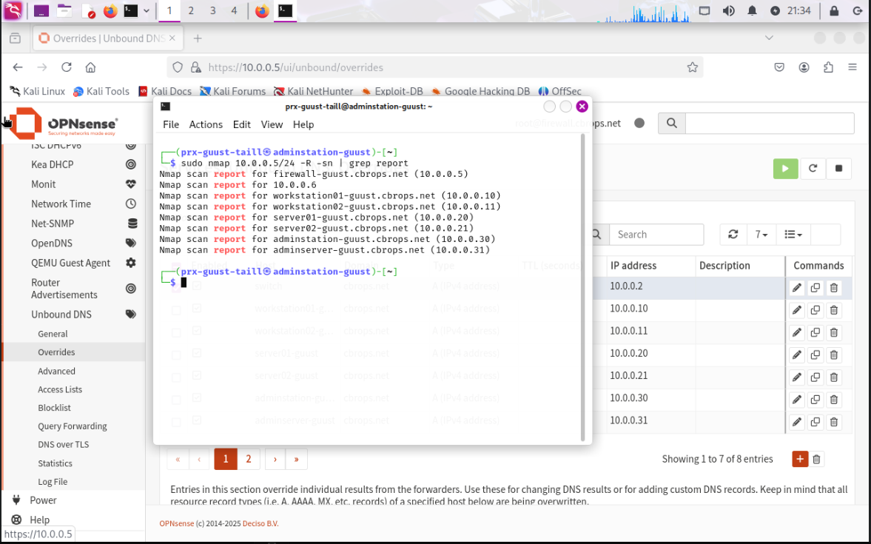

hostname | IP address | Subnet mask | Default Gateway | DNS | Operating System
firewall-guust | 10.0.0.5 | 10.0.0.255 | 10.0.0.5 | 10.0.0.5 | FreeBSD (But it is OpnSense)
/ | 10.0.0.6 | 10.0.0.255 | 10.0.0.5 | 10.0.0.5 | /
workstation01-guust | 10.0.0.10 | 10.0.0.255 | 10.0.0.5 | 10.0.0.5 | Ubuntu 25.04
workstation02-guust | 10.0.0.11 | 10.0.0.255 | 10.0.0.5 | 10.0.0.5 | Debian GNU/Linux 13
server01-guust | 10.0.0.20 | 10.0.0.255 | 10.0.0.5 | 10.0.0.5 | Debian GNU/Linux 12
server02-guust | 10.0.0.21 | 10.0.0.255 | 10.0.0.5 | 10.0.0.5 | Fedora Linux 41
adminstation-guust | 10.0.0.30 | 10.0.0.255 | 10.0.0.5 | 10.0.0.5 | Kali Linux 2025.1
adminserver-guust | 10.0.0.31 | 10.0.0.255 | 10.0.0.5 | 10.0.0.5 | Ubuntu 24.04.3
Table 3 Host documentation (final information)

